LOW-CODE PLATFORMS vs. TRADITIONAL SOFTWARE DEVELOPMENT
Submitted by:
Name: SHRIVARSHINEE K
Register Number: 241401099
Department: COMPUTER SCIENCE AND BUSINESS SYSTEMS
Course: LOW CODE-ZOHO CREATOR
Semester: V

Abstract

The rapid growth of digital transformation has increased the demand for efficient software development methods. This study compares low-code development and traditional application development based on factors such as development speed, cost, customization, scalability, security, and maintenance. Low-code platforms enable faster application development with minimal coding, while traditional development provides greater flexibility and control for complex applications. The study highlights the advantages, limitations, and suitable use cases of both approaches. It concludes that the choice between low-code and traditional development depends on an organization's business requirements, project complexity, budget, and long-term goals.

Introduction
Software applications are essential for improving business operations and delivering digital services. Traditionally, applications have been developed through manual coding, which offers high flexibility and customization but requires skilled developers, more time, and higher costs. In contrast, low-code development uses visual tools and pre-built components to simplify and speed up the development process with minimal coding. Both approaches have unique advantages and limitations depending on project requirements. This study compares low-code and traditional application development in terms of development speed, cost, scalability, security, customization, and maintenance to identify the most suitable approach for different software development needs.

Overview of Low-Code and Traditional Application Development:

Application development is the process of designing, building, testing, and maintaining software applications to meet user and business requirements. Two widely used approaches are low-code development and traditional application development. While low-code focuses on rapid development using visual tools and reusable components, traditional development relies on manual programming to build highly customized and scalable applications.

Comparison of Low-Code and Traditional Application Development

Feature | Low-Code Development | Traditional Application Development
Definition | Uses visual tools and minimal coding to build applications. | Uses manual programming to develop applications from scratch.
Development Speed | Faster due to drag-and-drop components and reusable modules. | Slower because of extensive coding and testing.
Coding Requirement | Minimal coding required. | Extensive coding required.
Customization | Limited by platform capabilities. | Highly customizable with full control over the application.
Development Cost | Lower development and maintenance costs. | Higher development and maintenance costs.
Target Users | Business users, citizen developers, and developers. | Professional software developers.
Scalability | Suitable for small to medium-sized applications. | Ideal for large-scale and enterprise applications.
Security | Platform-managed security with limited customization. | Complete control over security implementation.
Maintenance | Easier due to platform-managed updates. | Requires continuous maintenance by developers.
Common Use Cases | Workflow automation, internal business applications, and rapid prototyping. | Enterprise software, banking systems, healthcare applications, and large-scale web platforms.

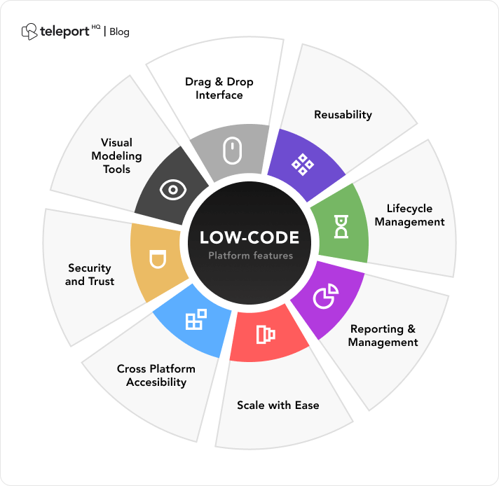
Architecture of Low-Code and Traditional Application Development

Low-Code Development Architecture
Low-code architecture consists of multiple layers that enable rapid application creation using visual tools and reusable components. The main layers include:
Layer | Description
User Interface Layer | Provides visual design tools, forms, dashboards, and user interaction components.
Application Logic Layer | Manages workflows, business rules, and application processes using visual models.
Data Layer | Handles data storage, databases, and connections with external data sources.
Integration Layer | Enables communication with external systems through APIs and connectors.
Platform Layer | Provides security, deployment, hosting, and application management services.

Traditional Application Development Architecture
Traditional application architecture is generally based on a layered structure where each component is developed manually using programming languages and frameworks.
Layer | Description
Presentation Layer | Handles the user interface and interaction between users and the application.
Business Logic Layer | Contains application rules, calculations, and core functionality.
Data Access Layer | Manages communication between the application and databases.
Database Layer | Stores and manages application data.
Infrastructure Layer | Provides servers, networks, security, and deployment environments.

Examples of Low-Code and Traditional Application Development

Low-Code Development Examples
Low-code platforms are widely used by organizations to build applications quickly with minimal coding. Some common examples include:
- Microsoft Power Apps – Used for creating business applications, automating workflows, and connecting different data sources through visual development tools.
- Mendix – A platform used for developing enterprise applications with reusable components and model-driven development.
- OutSystems – Helps organizations create web and mobile applications rapidly with built-in deployment and integration features.
- Appian – Commonly used for business process automation, workflow management, and enterprise applications.
- Zoho Creator – Allows users to create customized business applications using drag-and-drop features.

Traditional Application Development Examples
Traditional development is used for applications that require high performance, advanced security, and complete customization. Examples include:
- Amazon E-commerce Platform – Developed using traditional software engineering practices to handle millions of users, transactions, and large-scale operations.
- Netflix Streaming Platform – Uses custom-developed systems to support global streaming services and high scalability.
- Banking Applications – Built using traditional development methods to ensure secure transactions, data protection, and reliability.
- Healthcare Management Systems – Require customized software to manage patient records, medical data, and regulatory requirements.
- Enterprise Resource Planning (ERP) Systems – Developed to manage complex business processes, resource planning, and large organizational operations.
These examples show that low-code development is mainly suitable for rapid business solutions and automation, while traditional development is preferred for complex applications requiring maximum control, performance, and scalability.
ADVANTAGES AND DISADVANTAGES:
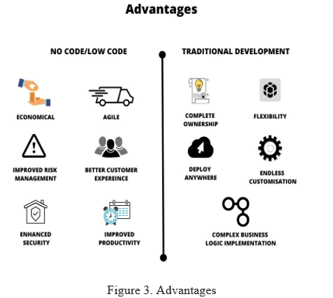
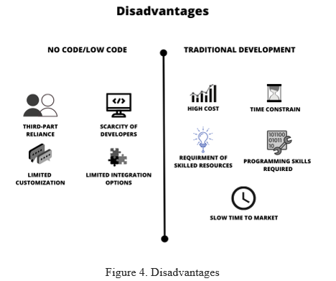

Summary
Low-code development and traditional application development are two important approaches used for building software applications. Low-code development focuses on faster development, reduced cost, and ease of use through visual tools and reusable components. It is suitable for business applications, workflow automation, and rapid application delivery. Traditional application development provides greater flexibility, customization, performance, and control, making it suitable for complex and large-scale systems.
The comparison shows that neither approach is completely superior; the choice depends on project requirements, budget, complexity, and long-term goals. Organizations can select low-code solutions for quick and simple applications, while traditional development remains the preferred choice for highly customized and performance-critical applications.

Recommendations
Based on the comparative study, the selection between low-code development and traditional application development should be based on project requirements, complexity, budget, and future objectives.
Low-code development is recommended for organizations that require rapid application delivery, business process automation, prototypes, and applications with standard functionalities. It is especially useful when reducing development time and cost is a priority.
Traditional application development is recommended for complex, large-scale, and performance-critical applications that require advanced customization, high security, and complete control over the system architecture. It is suitable for industries such as banking, healthcare, and enterprise software.
Organizations should adopt a balanced approach by combining both methods where appropriate. Low-code platforms can be used for quick development of simple applications, while traditional development can be applied for core systems requiring greater flexibility and scalability. A careful evaluation of business needs, technical requirements, and available resources will help organizations choose the most effective development approach.

Conclusion
Low-code and traditional application development both have important roles in software development. Low-code offers faster development, lower cost, and easier application creation, while traditional development provides greater customization, flexibility, and performance. The selection of the right approach depends on project requirements, complexity, budget, and scalability needs. Organizations should choose the method that best meets their business goals and technical requirements.

